PHASE 7 — PROJECT DOCUMENTATION
INTRODUCTION :
Project Title : BlogNest AI
Team ID : SWTID-2026 4186
Team Leader : Vishal A
MAIL ID: vishalken321@gmail.com
Team members :
NAME | MAIL ID
Hariprakash G | hari623406@gmail.com
Sudharshan S | Sudhansasi30@gmail.com
Documentation Prepared
- Project report covering all 8 phases, with Team ID SWTID-2026 4186.
- API details, setup instructions and a public GitHub repository with README.
- Screenshots of API testing using Thunder Client, shown below.
Screenshots
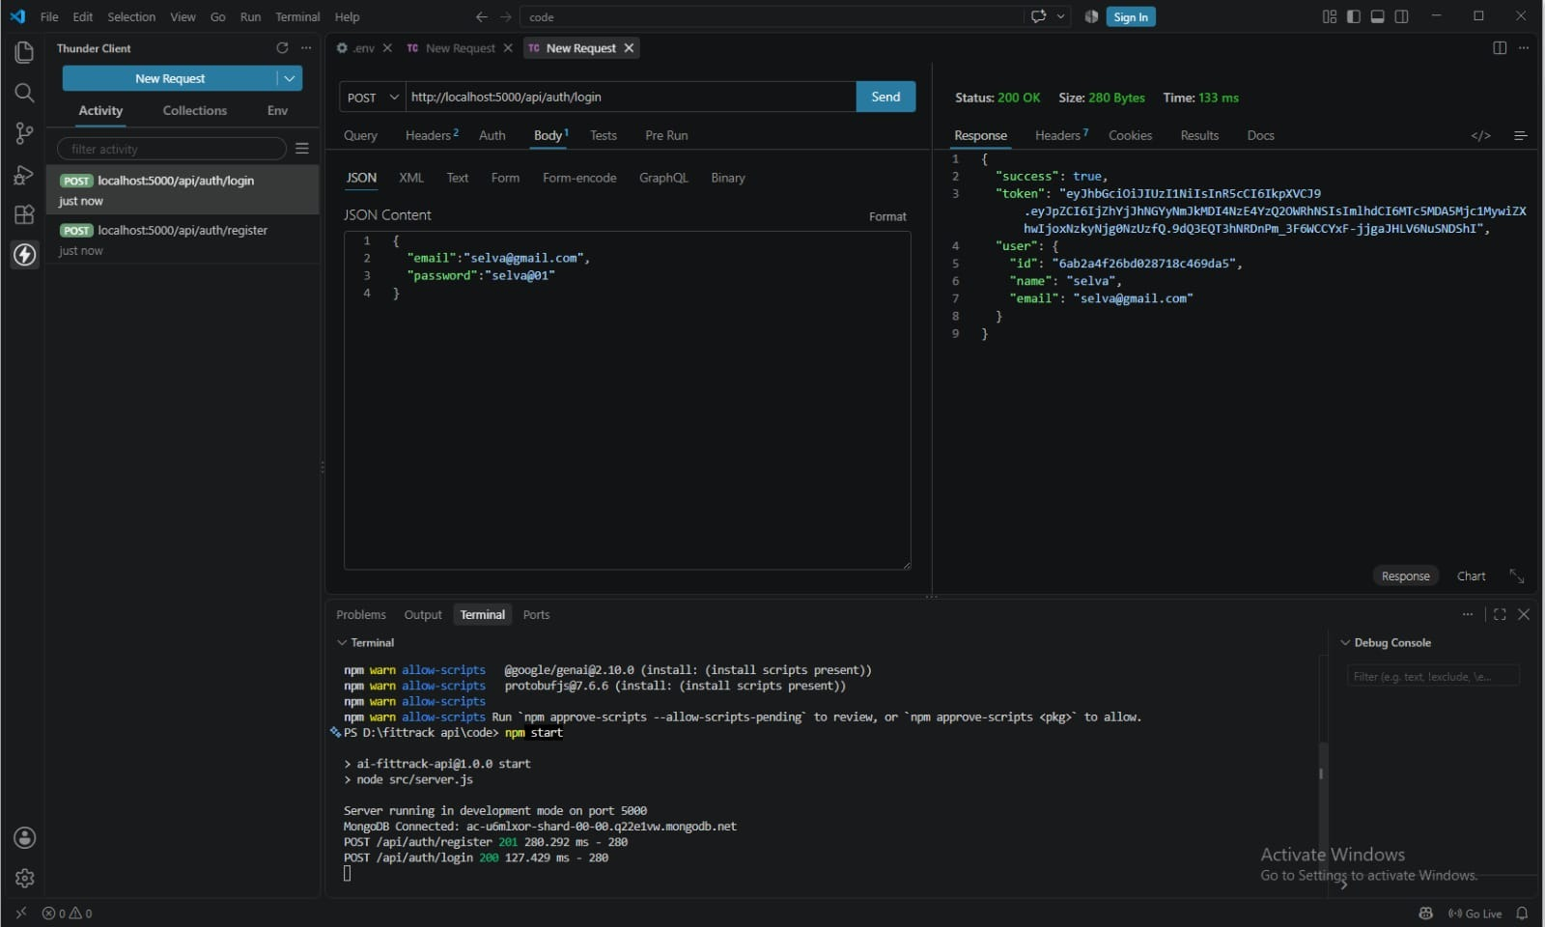  Figure 1: User login – POST /api/auth/login (200 OK, JWT token returned) | 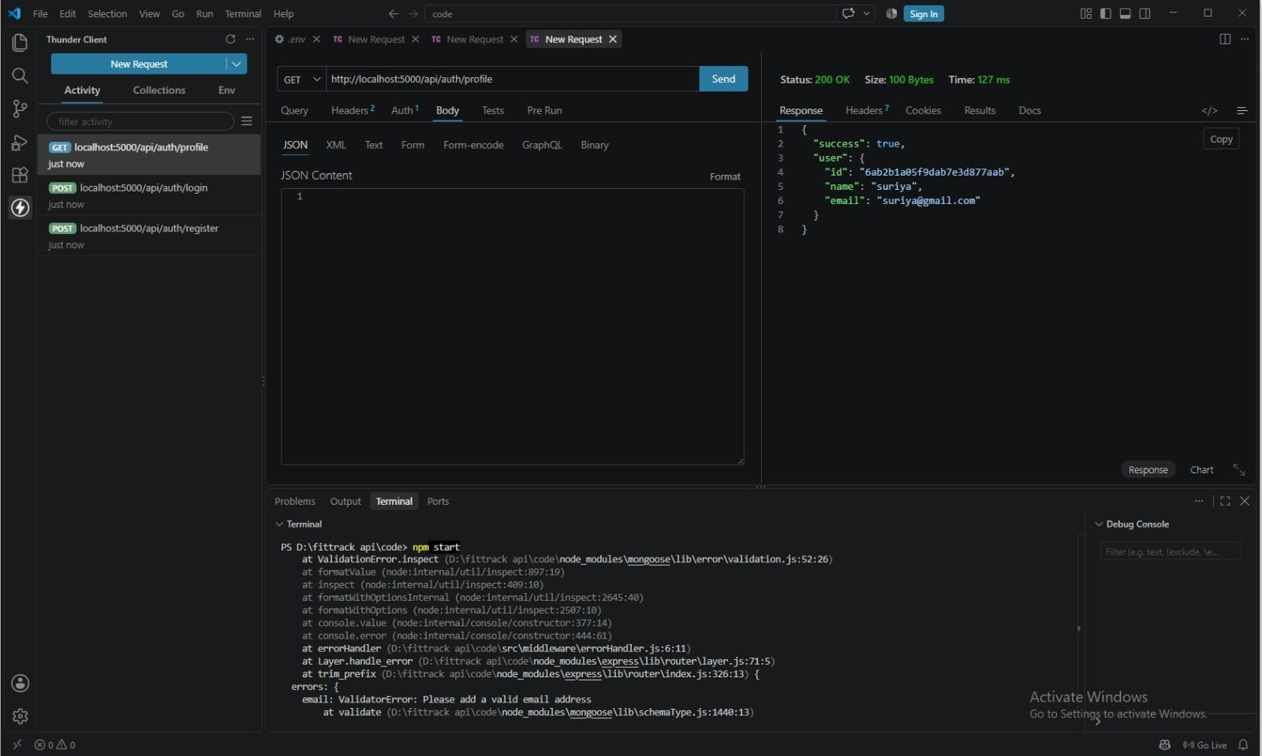  Figure 2: Protected profile – GET /api/auth/profile (200 OK)
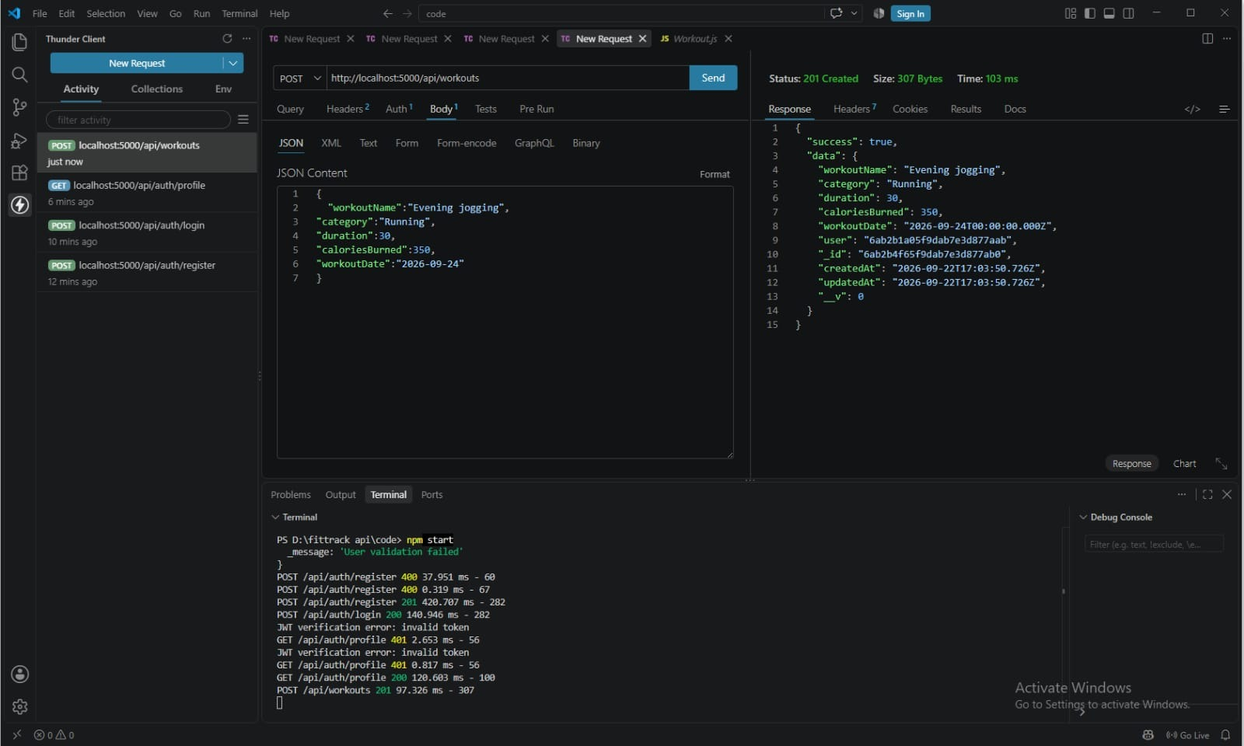  Figure 3: Create record – POST /api/workouts (201 Created) | 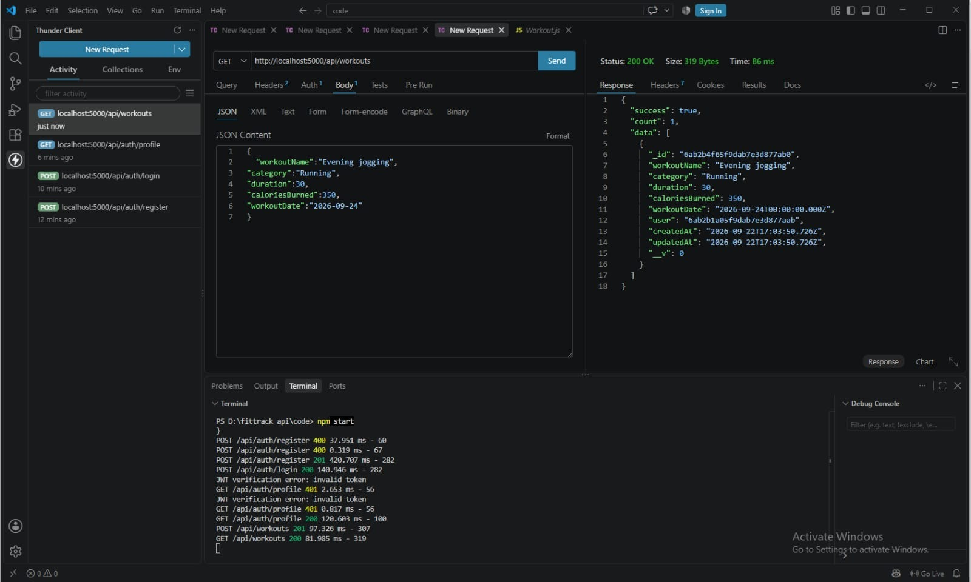  Figure 4: List records – GET /api/workouts (200 OK)

PHASE 7 — PROJECT DOCUMENTATION (CONTINUED)
Screenshots (continued)
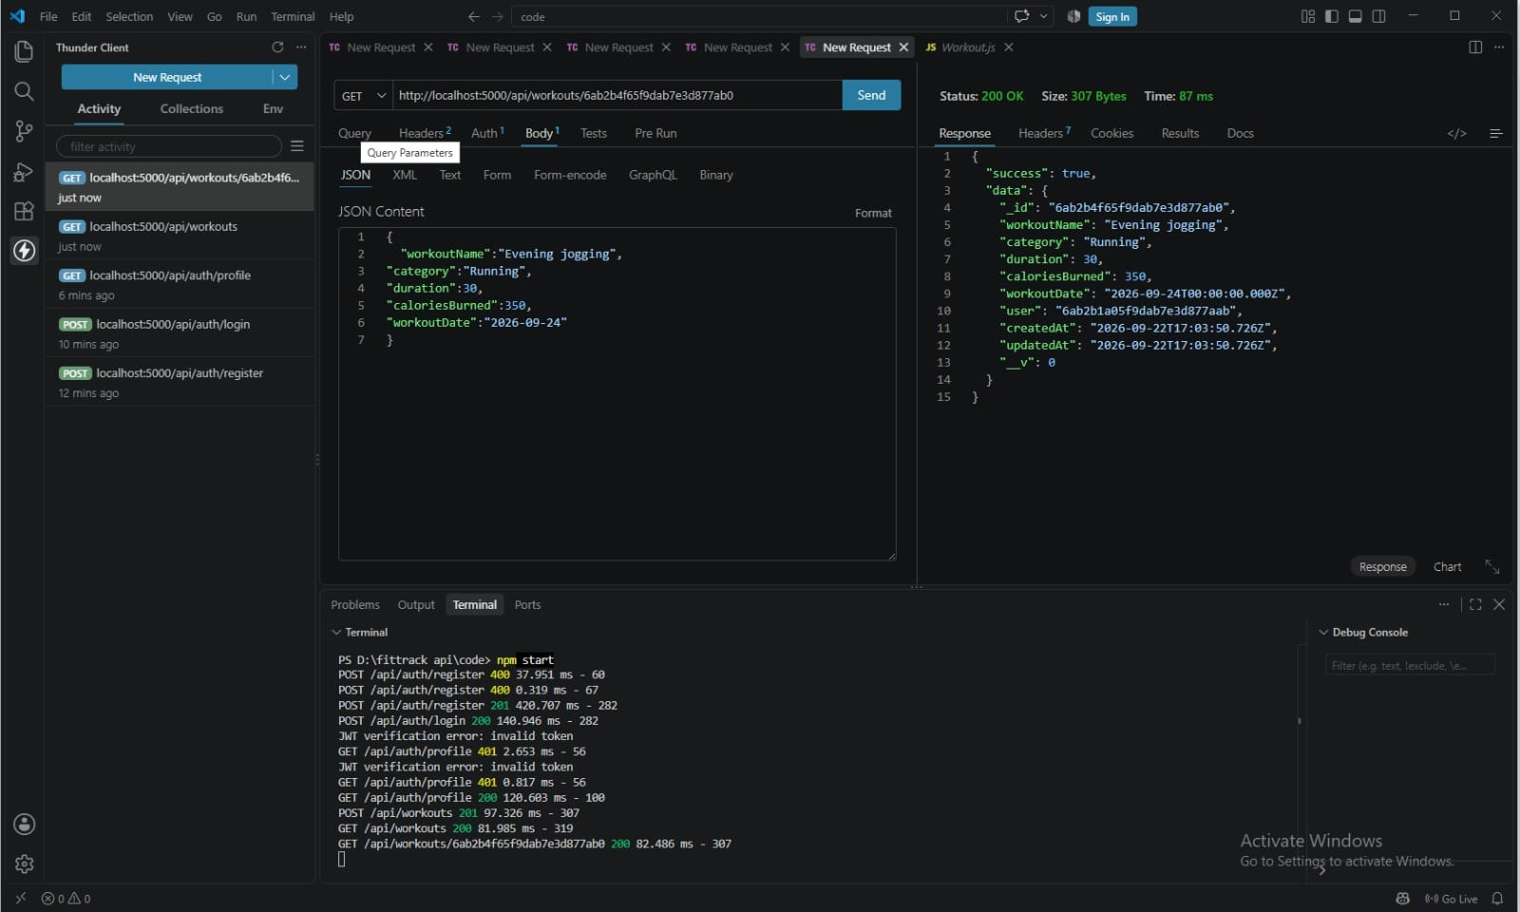  Figure 5: Get one record – GET /api/workouts/:id (200 OK) | 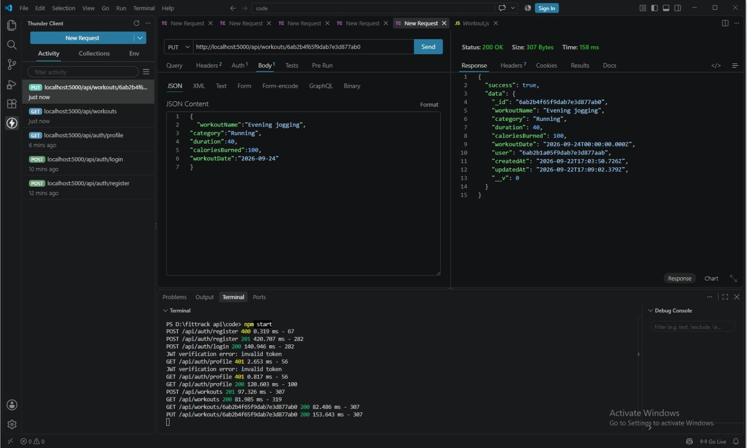  Figure 6: Update record – PUT /api/workouts/:id (200 OK)
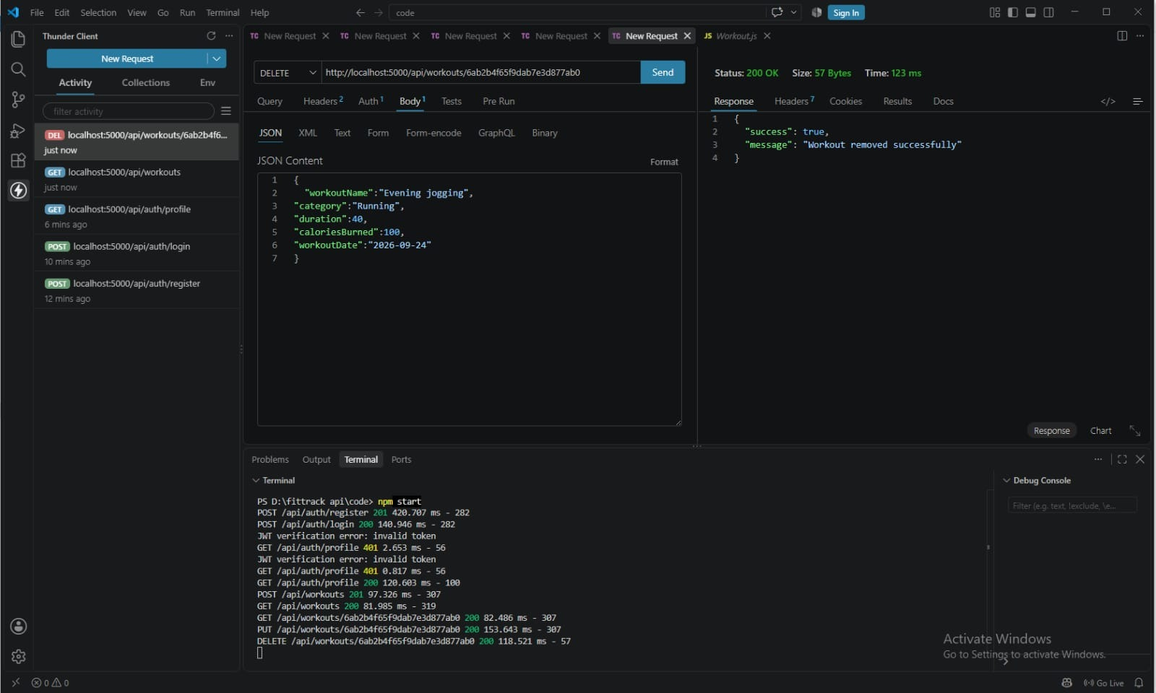  Figure 7: Delete record – DELETE /api/workouts/:id (200 OK) | 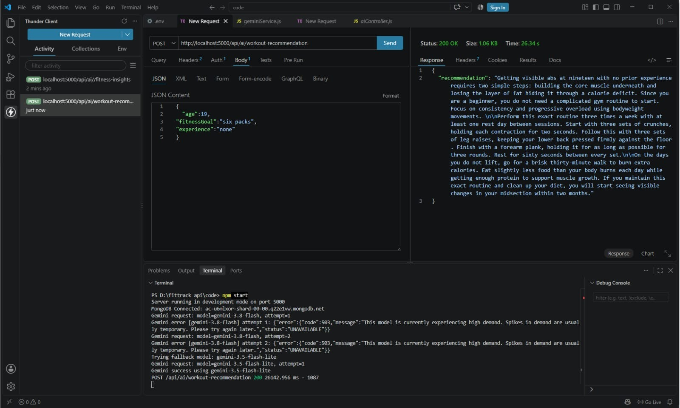  Figure 8: AI generation – POST /api/ai/workout-recommendation (200 OK)
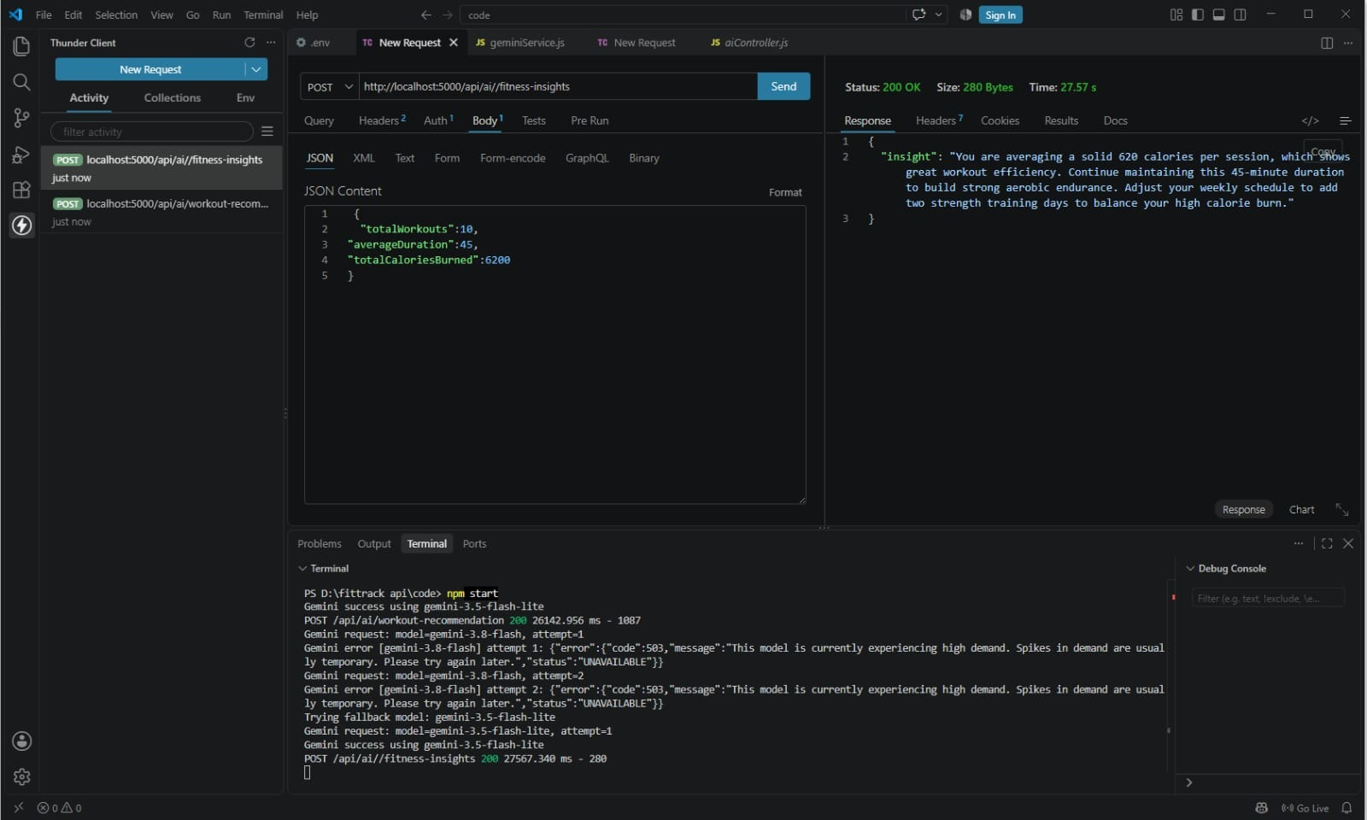
Figure 9: AI generation – POST /api/ai/fitness-insights (200 OK)

